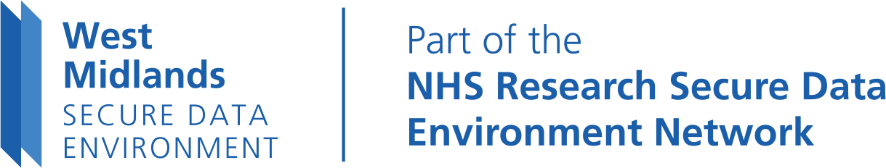

West Midlands SDE Local Data Opt-In Form
Please complete in BLOCK CAPITALS. If you’re doing this on behalf of another adult, or you’re signing on behalf of someone under 13 for whom you have parental responsibility, put their details in Section A and your own in Section B.

Where to send this form
Please email the form to WMSDEOptout@uhb.nhs.uk, or post it to the address shown on the
West Midlands SDE website’s Local Data Opt-Out page.
You’ll find this at https://westmidlandssde.nhs.uk/your-data/local-data-opt-out/.

Section A: Complete for the person who wants to opt in – either yourself or someone else
Title: Last name: Forename(s):
Address:

Postcode: Email:
Date of birth: NHS number (if known):

Section B: Only to be completed if you are a representative acting on behalf of a person who wants to opt in, or are signing on behalf of someone under 13 for whom you have parental responsibility
Your name:
Relationship to person who wants to opt in:
I confirm I have authority to act for the person who wants to opt in/I have parental responsibility for the person who wants to opt in.
I understand there may be circumstances that mean further checks are needed to ensure correct information is provided when someone is acting for another, or signing on behalf of someone for whom they have parental responsibility.

Declaration
By signing below, I confirm I am asking that my records/the records of the person for whom I have parental responsibility/authority to act are made available to view through the West Midlands Secure Data Environment and I consider I have the authority to make such a request/sign on their behalf. I understand the information provided will be used to process the request. I acknowledge that if the form is completed with the intent to be inaccurate, mislead or falsely represent myself as the person detailed in section A or B then the application may be refused.
Full printed name: Date:
Signature:

Office use only
Date received Date identity checked and confirmed Date response sent

